# Assignment 5

**Tasks 1: Database Design:**

1. Create the database named "TicketBookingSystem".



2. Write SQL scripts to create the mentioned tables with appropriate data types, constraints, and relationships.

• Venu

• Event

• Customers

• Booking

4. Create appropriate Primary Key and Foreign Key constraints for referential integrity.

* Primary Keys:
  + Venu: venue_id
  + Event: event_id
  + Customer: customer_id
  + Booking: booking_id
* Foreign Keys:
  + Event: venue_id references Venu (venue_id)
  + Event: booking_id references Booking (booking_id)
  + Customer: booking_id references Booking (booking_id)
  + Booking: customer_id references Customer (customer_id)
  + Booking: event_id references Event (event_id)

**Tasks 2: Select, Where, Between, AND, LIKE:**

1. Write a SQL query to insert at least 10 sample records into each table.

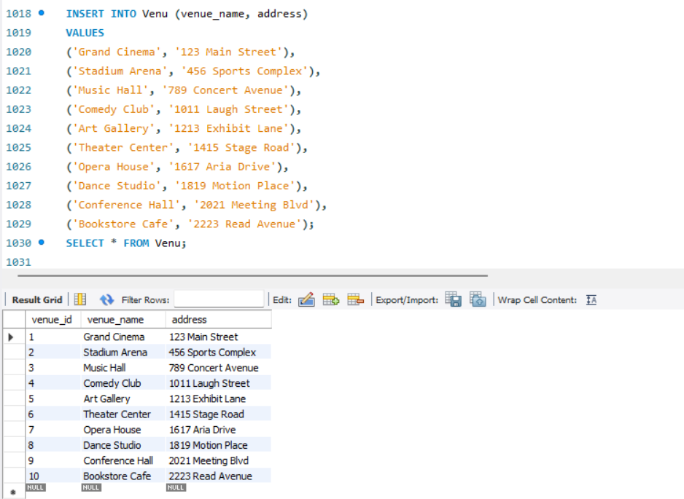

2. Write a SQL query to list all Events.

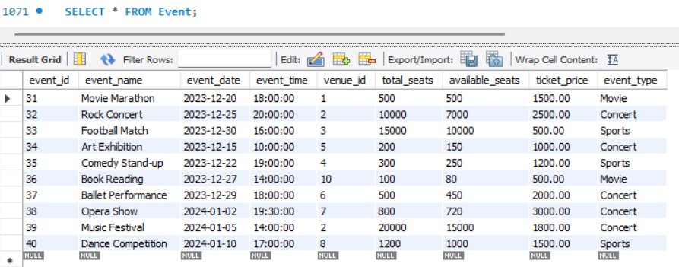

3. Write a SQL query to select events with available tickets.

4. Write a SQL query to select events name partial match with ‘cup’.

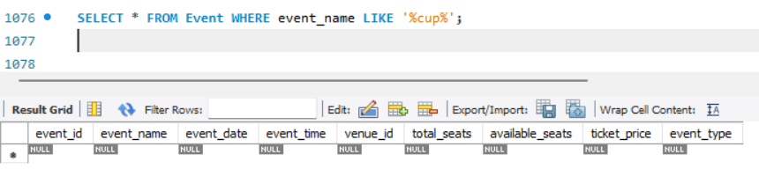

5. Write a SQL query to select events with ticket price range is between 1000 to 2500.

6. Write a SQL query to retrieve events with dates falling within a specific range.

7. Write a SQL query to retrieve events with available tickets that also have "Concert" in their name.

8. Write a SQL query to retrieve users in batches of 5, starting from the 6th user.

9. Write a SQL query to retrieve bookings details contains booked no of ticket more than 4.

10. Write a SQL query to retrieve customer information whose phone number end with ‘000’

11. Write a SQL query to retrieve the events in order whose seat capacity more than 15000.

12. Write a SQL query to select events name not start with ‘x’, ‘y’, ‘z’

**Tasks 3: Aggregate functions, Having, Order By, GroupBy and Joins:**

1. Write a SQL query to List Events and Their Average Ticket Prices.

2. Write a SQL query to Calculate the Total Revenue Generated by Events.

3. Write a SQL query to find the event with the highest ticket sales.

4. Write a SQL query to Calculate the Total Number of Tickets Sold for Each Event.

5. Write a SQL query to Find Events with No Ticket Sales.

6. Write a SQL query to Find the User Who Has Booked the Most Tickets.

7. Write a SQL query to List Events and the total number of tickets sold for each month.

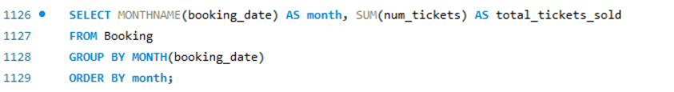

8. Write a SQL query to calculate the average Ticket Price for Events in Each Venue.

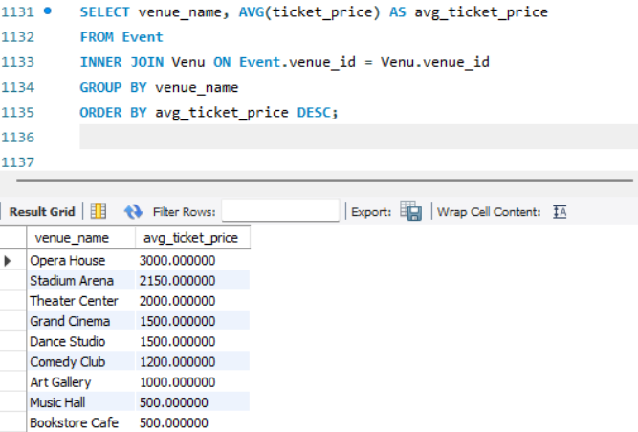

9. Write a SQL query to calculate the total Number of Tickets Sold for Each Event Type.

10. Write a SQL query to calculate the total Revenue Generated by Events in Each Year.

11. Write a SQL query to list users who have booked tickets for multiple events.

12. Write a SQL query to calculate the Total Revenue Generated by Events for Each User.

13. Write a SQL query to calculate the Average Ticket Price for Events in Each Category and Venue.

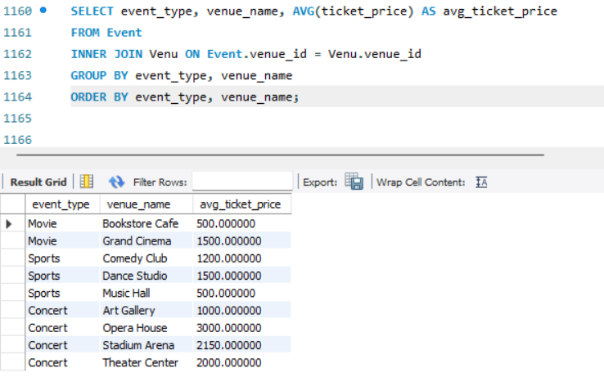

14. Write a SQL query to list Users and the Total Number of Tickets They've Purchased in the Last 30 Days.

**Tasks 4: Subquery and its types**

1. Calculate the Average Ticket Price for Events in Each Venue Using a Subquery.

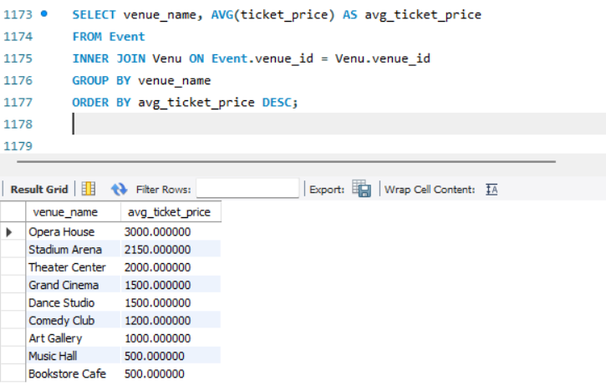

2. Find Events with More Than 50% of Tickets Sold using subquery.

3. Calculate the Total Number of Tickets Sold for Each Event.

4. Find Users Who Have Not Booked Any Tickets Using a NOT EXISTS Subquery.

5. List Events with No Ticket Sales Using a NOT IN Subquery.

6. Calculate the Total Number of Tickets Sold for Each Event Type Using a Subquery in the FROM Clause.

7. Find Events with Ticket Prices Higher Than the Average Ticket Price Using a Subquery in the WHERE Clause.

8. Calculate the Total Revenue Generated by Events for Each User Using a Correlated Subquery.

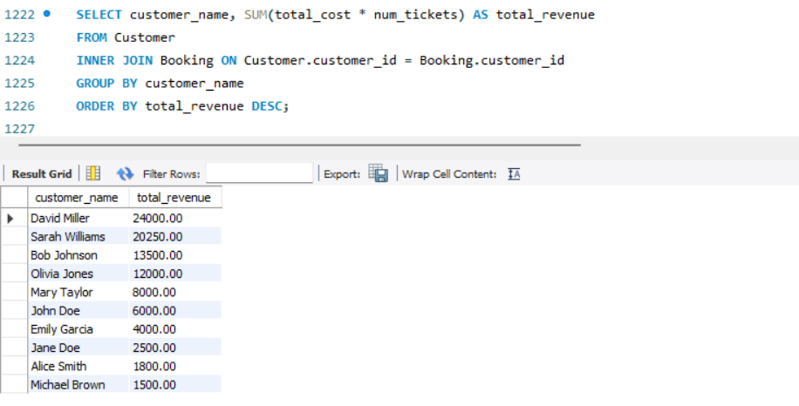

9. List Users Who Have Booked Tickets for Events in a Given Venue Using a Subquery in the WHERE Clause.

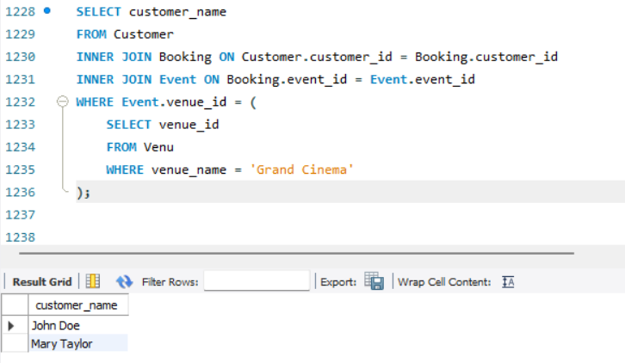

10. Calculate the Total Number of Tickets Sold for Each Event Category Using a Subquery with GROUP BY.

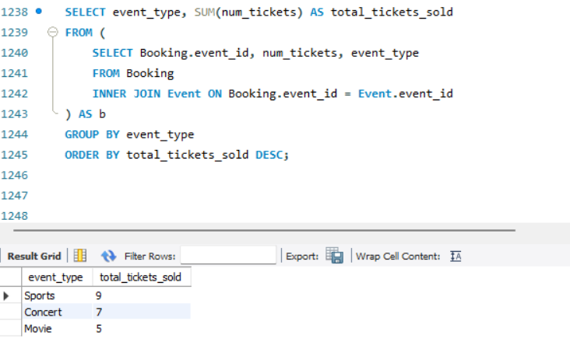

11. Find Users Who Have Booked Tickets for Events in each Month Using a Subquery with DATE_FORMAT.

12. Calculate the Average Ticket Price for Events in Each Venue Using a Subquery

